Extension task 2.2 - Thursday
Q1 and 2
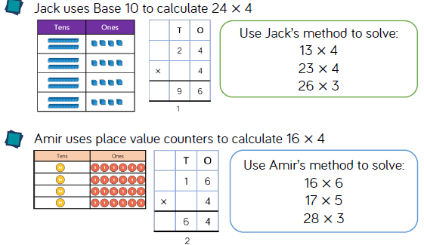
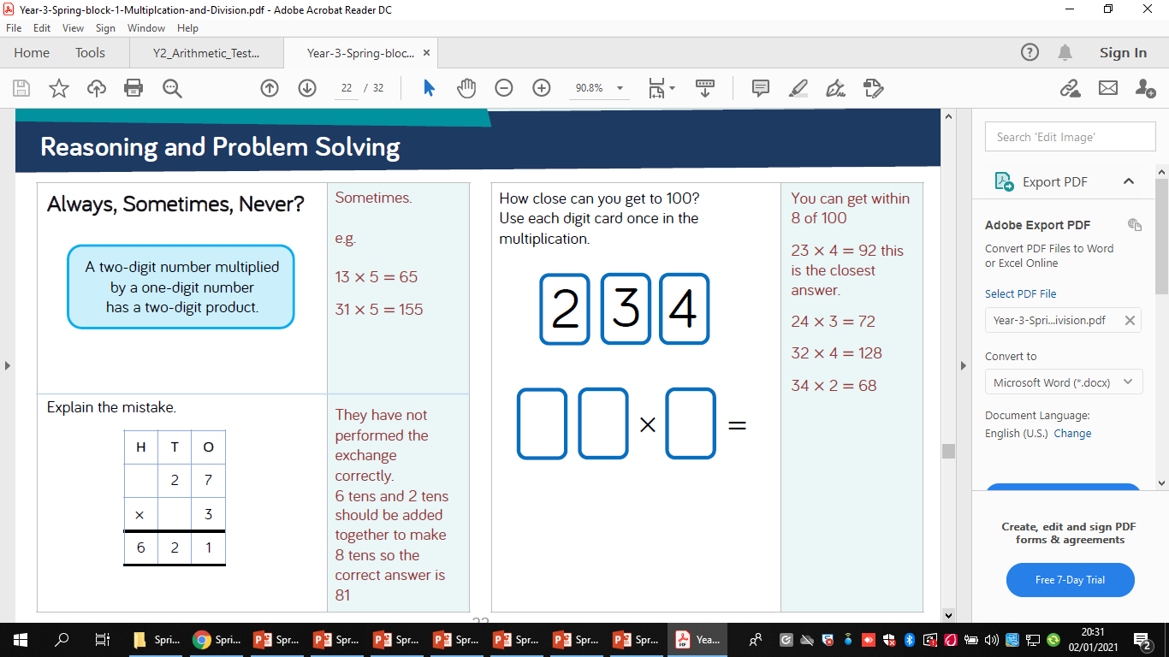
3
4.
5.

